Computer Workshop 5: Linear models with a categorical predictor
Roos & Pinard
Last updated: 2024-09-17
Table of Contents

Workshop Structure
As always, we are using the workflow below to structure the workshops:
- Formulate a research question.
- Perform exploratory data analysis.
- Identify any hidden assumptions.
- Fit an appropriate model [Focus of today].
- Diagnose the model and check assumptions.
- Summarise the results.
- Interpret and provide inferences.

1. Formulate a Research Question
For this workshop on fitting a linear model with a single categorical explanatory variable (or “predictor”, etc), we’re going to be using a new dataset. Our dataset this week comes from Japan, specifically the Ryukyu islands, far to the south of mainland Japan. Two islands, in particular, are home to the Amami rabbit (Pentalagus furnessi), a particularly ancient species of rabbit and designated a “natural monument” of Japan, currently threatened due to the invasive Java mongoose.
We’ve been contacted by researchers in Japan asking us if we can help answer if the invasive species may be causing rabbit size to decline. For this they are providing a dataset of rabbit weights from two islands; Oshima, where mongoose are present, and Tokunoshima, where mongoose are believed to be absent. Mongoose are known to be present on Oshima (multiple captures with a control program underway) while on the smaller island of Tokunoshima there have been no reported sightings by locals of mongoose.
- weight: The weight of the Amami rabbit.
- mongoose: Whether the rabbit was on the island with mongoose present (Oshima), or not (Tokunoshima.)

2. Perform Exploratory Data Analysis
Given this is a new dataset, we need to check for any data issues. But before we begin, our colleagues in Japan email to note two data entry mistakes. In their email, they report:
Mistake 1: * The rabbit in the 7th row was actually from Oshima, not Tokunoshima.
Mistake 2: * We cannot remember which rabbit, but we accidentally added 100 to its weight.
They ask you to resolve these issues but also to check for any other possible mistakes.

Question Set One
- What mongoose value should the first mistake have?
# We've been told this is the 7th row, so we can use square brackets to check this row. Here, I'll also ask for all columns of the 7th row (by not speciying anything after the ,):
rabbit[7,]
1.5 Correct the above data entry mistake and confirm that you’re correction has worked
# The rabbit was from Oshima, not Tokunoshima, so mongoose should be Present not Absent
# We can resolve this in a number of ways, but here are two options:
rabbit$mongoose[7] <- "Present"
rabbit[7,1] <- "Present"
# Both do the exact same thing. If you're not sure why, ask a demonstrator.
# To check if this worked, we can do:
rabbit[7,]
- Which rabbit had the incorrect weight? (Correct the data entry mistake at the same time)
# If we do a plot of the data:
ggplot(rabbit) +
geom_histogram(aes(x = weight))
## `stat_bin()` using `bins = 30`. Pick better value with `binwidth`.
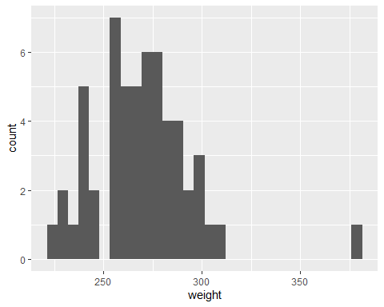
# We can clearly see there's one rabbit that's much larger than the others. From the figure, we can also see that it's the only rabbit that's larger than 350 g, so we can use that as our condition and subtract 100 g. We also learn that this is on row 41 (the number oto the left of the output).
rabbit[rabbit$weight > 350,]
2.5 Correct the above data entry mistake and confirm that you’re correction has worked
# There are a couple of different ways we can do this correction:
rabbit$weight[rabbit$weight > 350] <- rabbit$weight[rabbit$weight > 350] - 100
# Or we can do:
# rabbit[41,2] <- rabbit[41,2]-100 #Not run
# To check if this worked, we can do:
rabbit[41,]
# Or:
ggplot(rabbit) +
geom_histogram(aes(x = weight))
## `stat_bin()` using `bins = 30`. Pick better value with `binwidth`.
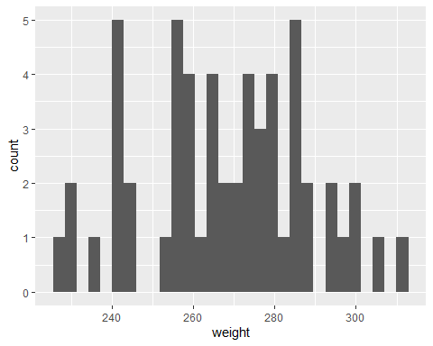
- Can you find any additional data entry mistakes?
# No, nothing that I can spot at least.

3. Identify Any Hidden Assumptions
Having resolved any data issues, it’s time to think more carefully about that data and identify any hidden assumptions. Note that when people talk about “hidden assumptions” they generally mean those assumptions that generally can’t be easily checked for using diagnostic plots; so especially validity and representativeness, but it can really mean any assumption we make when we use a dataset to try and understand the world.

Question Set Two
- Can you already identify any hidden assumptions with this dataset?
# It's unclear if mongoose are actually absent from Tokunoshima or not. All we know is that none of the island residents have *reported* any sightings. That doesn't mean the mongoose aren't there. It's possible there's just a very small population of mongoose on an island that doesn't have a huge number of people to spot them.
# It's possible we're going to break to assumption of validity with this analysis.
- If you have identified any issues, can we do anything about it/them?
# Ideally we'd want to confirm the absence of mongoose on Tokunoshima in some way but, in this case, we can't [we can't pay for the class to go on a trip to some tropical islands in Japan :(]. So we have two options. 1) Don't perform the analysis due to the possibility that we'll break an important assumption, or 2) Perform the analysis and place clear, obvious and unambiguous statements highlighting this caveat and limitation to our analysis.
# Either of the two options are fine (in real life) but given the fundamental aim here is for you to learn the method, we'll go with option 2.
# (If this were a real project that I was involved in, I'd push very hard to try and confirm that lack of mongoose on Tokunoshima before doing any analysis. If that weren't possible, then personally I'd probably pull out of the project (option 1) but others would go with option 2.)
- If there are mongoose on Tokunoshima, what effect would that have on any analysis we might perform?
# If there are mongoose on both islands, then assuming mongoose *do* decrease weight, then we'll either find no difference in weight, or a very small difference in weight - i.e. if there are mongoose on both islands, and mongoose decrease weight, then rabbit weight will be more-or-less identical on both islands.
# The annoying thing is that it could also be that mongoose don't impact rabbit weight. So finding no difference or small differences in weights can mean multiple things. Either there are mongoose on both islands, or mongoose don't affect rabbit weight.

4. Fit an appropriate model.
Assuming you are happy to proceed to analysis, let’s think what this model will look like:
$weight_{i}∼Normal\left(μ_{i},σ\right)$
μi=β0+β1×Presenti
Where:
- $weight_{i}$ is the weight of rabbit $i$, assumed to follow a $Normal$ distribution with a mean of $μ_{i}$ (what the model predicts for rabbit $i$) and a standard deviation of $σ$.
- $μ_{i}$ is defined by $β_{0}$ and $β_{1}$

Question Set Three
If you’re struggling to answer the questions below, you can always skip ahead to running the model, and then come back to these questions, using the model summary to help you.
- What replaces the blank part of the above equation?
# "Present" will replace the blank part
# If you said "mongoose", keep in mind that mongoose has two values "Present" and "Absent", which cannot be used in an equation. Instead we use one of these groups (or "levels") and convert it to a binary variable (i.e. either 1 or 0), which we can use in an equation
# R will take whichever group is earliest in the alphabet and use that as our reference. So here, R will choose Absent as the reference, and create a dummy variable for Present. That means that when Present == 0, then it must be Absent.
- What does the parameter $β_{0}$ represent?
# This is the weight of our rabbits when they are in our reference group, or when mongoose are *not* "Present".
- What does the parameter $β_{1}$ represent?
# This is the difference in weight of rabbits when mongoose are present, compared to beta_0.
Let’s run our linear model:
rabbit_mod <- lm(weight ~ mongoose, data = rabbit)
Having run the model, let’s see what the parameters $β_{0}$ and $β_{1}$ have been estimated as, using summary():
summary(rabbit_mod)

Question Set Four
- Replace the blank areas of the equation with the values that have now been estimated by the model.
$weight_{i}∼Normal\left(μ_{i},σ\right)$
μi=β0+β0×Presenti
# The first blank should be 272.447 and the second blank should be -5.335
# Or mu = 272.5 + -5.3 * Present
- Using your completed equation from 1., what value of $μ$ (or Amami rabbit weight) would you predict if there are mongoose present?
# We can just replace the drought from the above equation with zero:
# 272.5 + -5.3 * 1 = 267.2
- Using your completed equation from 1., what value of $μ$ would you predict if mongoose were absent?
# We can just replace the drought from the above equation with eight:
# 272.5 + -5.3 * 0 = 272.5
- Is the presence mongoose associated with a decline in weight as the Japanese researchers hypothesised?
# Based on the model, yes, mongoose appear to reduce the average weight of rabbits by about 5 grams.
- Is the association sufficient to be of biological concern?
# Five grams is pretty small, given the rabbits weight on average 2.7 kg. Combined with the uncertainty of whether or not mongoose are actually absent from Tokunoshima, we're not really sure what we've learned here.
# I.e. we identified before running the model that the mongoose variable might not be reliable, and we now find a tiny effect of mongoose on rabbit weight. So what should we take away from this? I'm not sure myself.

5. Diagnose the model and check assumptions.
We’ll cover this on Friday.

6. Summarise the results.
We’ll come back to “5. Diagnose the model and check assumptions.” on Friday. For today we’ll go through how to take these results and convert them into a figure.
Just like last week, we’ll use two options to plot our model results:
- Option 1: Use the ggeffects package to create the figure for you.
- Option 2: Create the prediction and figure yourself.

ggeffects
Make sure you load ggeffects (and make sure it’s installed if you didn’t do so last week):
library(ggeffects)
## Warning: package 'ggeffects' was built under R version 4.3.3
Then ask ggeffects to predict rabbit weight for each of our mongoose categories:
preds <- ggpredict(rabbit_mod)
## Warning: Some of the focal terms are of type `character`. This may lead to
## unexpected results. It is recommended to convert these variables to
## factors before fitting the model.
## The following variables in are of type character: `mongoose`
When we run the above code, we get a Warning (but not an Error) saying that, basically, ggeffects isn’t happy about using a character to do this predictions. Instead it recommends to convert these variables to factors before fitting the model. Doing so is easy enough, we’d just do:
rabbit$mongoose <- factor(rabbit$mongoose)
And then rerun our model. In truth, I’ve never found fitting a model with characters to be especially problematic, though some packages will not allow you to do this at all. So generally, I do convert my categorical variables to factors before fitting models. Whether you want to or not is up to you, but given how little effort it takes, I lean towards just converting to factor.
Regardless of whether you refit the model with mongoose as a factor or character, now we just need to plot it:
plot(preds)
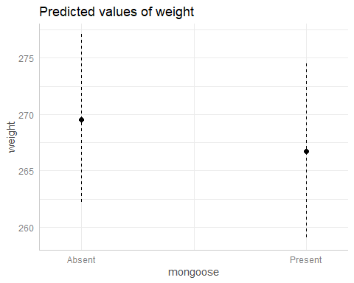
Just like last week, we get a figure quickly and easily that shows our model predictions along with the 95% confidence intervals.

Create the prediction and figure yourself.
We can also, broadly, repeat the process we used last week, with only a few minor tweaks to account for the different type of explanatory variable (from continuous to categorical).
For starters, when we make our fake dataset, the values of mongoose need to only be Present or Absent (just like in our actual dataset). To create our mongoose variable, we can either use c("Absent", "Present") or we can use the unique() function that you may have used in the very first Workshop. unique() will return all unique values within a column of data, so unique(rabbit$mongoose), will return "Absent" and "Present". The benefit of using unique() is when we have categorical variables with many groups (or levels) and it becomes a real pain to write out all of the different groups.
Let’s use unique() now to create our fake dataset to predict from:
fake <- data.frame(
mongoose = unique(rabbit$mongoose)
)
fake
Giving us a very simple dataset with just mongoose and two rows. One for Absent and one for Present.
Last week we used our fake dataset to only make a prediction for the “mean fit” (i.e. predicted boto length). This week we’re also going to include uncertainty, specifically, we’re going to also include 95% confidence intervals.
To do so, we need to add in some additional steps. For starters, because predict() is going to give us both the fit (i.e. predicted rabbit weight), but also se.fit (i.e. the standard error for the fit), we can’t immediately add this to our fake dataset.
Instead, we’ll just put the output from predict() into a temporary dataset, which we’ll arbitrarily call preds:
preds <- predict(rabbit_mod, newdata = fake, se.fit = TRUE)
The next part is the same as last week, just with an extra step. We can just go into the preds object and extract $fit, and include this in our fake dataset:
fake$fit <- preds$fit

Confidence intervals
This next part is new. We’re going to use the standard error of the fit to calculate the 95% confidence intervals. If you need a reminder of what 95% CI are, then have a quick look at the lecture material, but very briefly, confidence intervals represent the probability that an interval will contain the true parameter values before the model has been run. Once the model has been run, well, then either the intervals contains the true value or it doesn’t. We don’t know if it does.
If that’s confusing (which is fair, 95% CI are weird), then think of the example we went through in the lecture with the ring toss game, where if we make the hoop “big” we’ll have a 95% chance of hitting the target, but once we’ve thrown the hoop, it’s either on target or it isn’t.
The important technical thing to remember is that 95% CI take the standard error, multiplied by 1.96, and either subtract this from fit to get our lower 95% CI, or we add it to fit to get our upper 95% CI. Here’s how we do that:
fake$low95 <- preds$fit - 1.96 * preds$se.fit
fake$upp95 <- preds$fit + 1.96 * preds$se.fit
Now our fake dataset has all the values we need to do plot our results, using geom_errorbar() to add in the error bars to show our 95% CI:
ggplot(fake) +
geom_errorbar(aes(x = mongoose, ymin = low95, ymax = upp95)) +
geom_point(aes(x = mongoose, y = fit)) +
labs(x = "Java mongoose",
y = "Predicted weight of rabbits (g)") +
theme_minimal()
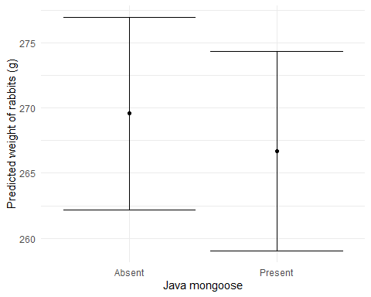

The full workflow
Here’s the entire workflow for the above analysis
# Deon Roos
# Analysis of Amami rabbit weight in relation to mongoose presence
# Load data
setwd("my/file/path")
rabbit <- read.table("rabbit.txt", header = T)
# EDA
summary(rabbit)
str(rabbit)
ggplot(rabbit) +
geom_histogram(aes(x = weight))
ggplot(rabbit) +
geom_point(aes(x = mongoose, y = weight))
# Correcting 2 data entries identified in EDA and through communication with researchers
rabbit$mongoose[7] <- "Present"
rabbit$weight[rabbit$weight > 350] <- rabbit$weight[rabbit$weight > 350] - 100
# Concerns prior to modelling
# Unclear if mongoose on one island are actually absent or just not detected, or not reported
# Ideally this would be resolved before continuing with analysis but we are unable to
# Analysis
rabbit_mod <- lm(weight ~ mongoose, data = rabbit)
# Diagnostics
# Covered in next workshop
# Inference
summary(rabbit_mod)
fake <- data.frame(mongoose = unique(rabbit$mongoose))
preds <- predict(rabbit_mod, newdata = fake, se.fit = TRUE)
fake$fit <- preds$fit
fake$low95 <- preds$fit - 1.96 * preds$se.fit
fake$upp95 <- preds$fit + 1.96 * preds$se.fit
ggplot(fake) +
geom_errorbar(aes(x = mongoose, ymin = low95, ymax = upp95)) +
geom_point(aes(x = mongoose, y = fit)) +
labs(x = "Java mongoose",
y = "Predicted weight of rabbits (g)") +
theme_minimal()

Question Set Five
- Once you’ve completed this analysis (not including model diagnostics, which we’ll cover on Friday), in groups, discuss whether you think these results should be shared with the local government as evidence to help them decide if mongoose eradication should continue or not.
# As said above, personally I have no idea what to make of this model given that the assumption of validity seems questionable (related to our uncertainty of mongoose being present or not in Tokunoshima).
# Making it even harder, the apparent effect of mongoose is tiny, just two gramms! - small enough that it could be something as silly as using two different sets of scales on both islands.
# The thing that would keep me up at night would be if anyone were to use our model to make any decisions that could have real world consequences, such as showing these results to the local government. Are we really confident enough in our model to have that rest on our conscious? I don't think I am.
# This last part is probably the hardest part of "statistics" and it has nothing to do with actual statistics; the equations, the distributions, etc, none of that matters now. It's all down to asking if the data is appropriate for answering our question.

A new challenger
Once you’re finished with the Amami rabbit dataset, move on to the lemur.txt dataset on MyAberdeen. This dataset comes from researchers who are interested in understanding how activity levels (i.e. how many hours a group of lemurs are active for in a day), varies across four habitat types.
The data contains:
- activity - the number of hours lemurs were active for (measured to two decimal places)
- habitat - one of four habitat types; Rainforest, Dry Forest, Spiny Forest, and Mangrove.
Go through the workflow you’ve just refined for fitting a linear model with a categorical explanatory variable and see which habitat type lemurs are most active in.
# This is how I would analyse the lemur data
# Deon Roos
# Analysis of lemur activity by habitat type
# In which habitat are lemurs most active
# Packages -------------------------------------
library(ggplot2) # For plotting
library(ggeffects) # For quick plotting of model fit
# Data -----------------------------------------
# (Not running these here because of how this document is created)
# setwd(H:/BI3010/)
# lemur <- read.table("lemurs.txt", header = TRUE)
# EDA ------------------------------------------
str(lemur)
# n = 120
summary(lemur)
# No apparent issues
ggplot(lemur) +
geom_histogram(aes(x = activity), colour = "white", binwidth = 0.5) +
theme_minimal()
ggplot(lemur) +
geom_histogram(aes(x = activity, fill = habitat),
colour = "white", binwidth = 0.5) +
theme_minimal()
# Data entry mistake spotted
# One habitat is recorded as "Rain forest" and not "Rainforest"
# Obviously a mistake, so happy to correct without confirmation
# Correcting data entry mistake -----------------
lemur$habitat[lemur$habitat == "Rain forest"] <- "Rainforest"
# Check if correction worked
ggplot(lemur) +
geom_histogram(aes(x = activity, fill = habitat),
colour = "white", binwidth = 0.5) +
theme_minimal()
# Hidden assumption ----------------------------
# - Validity - Unsure how activity is measured but must be hard. Seems possible that accuracy changes in different
# habitats? E.g. easier to keep track of lemurs in dry forest than rain forest?
# - Equal variance? - Seems likely that some amount of variation may differ between habitats? Something to check.
# Model fit ------------------------------------
lem_mod <- lm(activity ~ habitat, data = lemur)
# Diagnose -------------------------------------
# Left for Friday
# Summarise ------------------------------------
summary(lem_mod)
# Model predicts 7.9 hours of activity in Dry forests
# 1.05 hours *less* activity in Mangroves (so 6.85 hours total)
# 1.8 hours *more* activity in Rainforests (so 9.7 hours total)
# 1.8 hours *less* activity in Spiny Forests (so 6.1 hours total)
preds <- ggpredict(lem_mod)
plot(preds)
# Interpret -----------------------------------
# No issues identified in EDA (diagnoses on Friday) so can provide inference
# Lemurs most active in rain forests and least in spiny forests
# May not imply rain forests are more important - this is just where they are most active
# Potential that this may be biased by how easy it is to record activity in different habitats

Assumption table
Assumption | Description | Example of Violation
1. Validity | The data is able to answer the research question effectively. | Using IQ to measure overall intelligence (what does IQ even measure?).
2. Representativeness | The data reflects the population or group being studied. | Using survey data from a rural area to draw conclusions about an urban population.
3. Additivity | Effects of predictors are additive and there are no interactions between them. | Assuming that study hours and sleep hours independently affect exam scores without considering their combined effect (imagine a Venn diagram with study and sleep overlapping).
4. Linearity | The relationship between predictors and the outcome is linear. | Assuming plant growth will continue to increase indefinitely without ever levelling out.
5. Independence of Errors | Observations are independent of each other. (Related to residual errors.) | If modelling height, the data come from the same group of children over time.
6. Equal Variance of Errors | Residuals have constant variance across all levels of predictors (“homoscedasticity”). (Related to residual errors.) | If modelling income, variability in salaries is not the same across all levels of a company’s hierarchy.
7. Normality of Errors | Residuals should be normally distributed. (Related to residual errors.) | If modelling income, the presence of any extremely wealthy individuals will be hard for the model to understand and explain.

